Introductory note
During its first call the group has agreed to:
- Determine a handful of sub-themes to categorize workshops more easily, help create a thematic flow of sessions and determine any gaps to be filled to respond to the community’s interests expressed with the proposals made. The following sub-themes were suggested based on the Secretariat’s analysis and the group’s discussions:
  - Youth participation
  - Gender
  - Accessibility and persons with disabilities (PWD)
  - Skills, education and jobs
  - Access, affordability, infrastructure
  - Local content, multilingualism
  - Governance and overarching policy considerations
- Consider the top 16 workshops as provisionally approved and look at mergers already suggested for these sessions to avoid duplication
- Make proposals to fill gaps left by the top 16, especially in terms of geographic and stakeholder diversity and unaddressed issues
- Advise on scheduling of the selected workshops to ensure a comprehensive thematic flow that is easy to follow by participants
Between 21-24 May group members worked on the below document to make suggestions for:
- mergers for workshops in the top 16
- new workshops to be added to the Inclusion track
- organize workshops into a thematic flow
During its second call the group agreed to the following recommendations
1: Mergers and suggestions on top 16
Aim: Considering the top 16 ranked workshops as provisionally approved, the group looked to find synergies within the top 16 workshops that would help avoid duplication and allow for other proposals to be considered
Sub-theme as defined by the Working Group | Tags in proposal | WS number & title | WS rank in Inclusion track | Time | Proposal by the Digital Inclusion Working Group
Governance and overarching policy considerations | - Access  - Inclusive Governance  - Infrastructure | IGF 2019 WS #72 Inclusion and Legitimacy in Multistakeholderism at ICANN | 1 | 90 mins | Accept this WS as proposed
Governance and overarching policy considerations | - Access  - Digital Divide  - Economic Development | IGF 2019 WS #104 Integrated Policy Framework Key to Realize Digital Inclusion | 2 | 90 mins | Accept this WS as proposed and recommend organizers reach out to organizers of WS #96 Measuring and Bridging Digital Divides:Going Digital Toolkit to explore collaboration, as both workshops focus on the same toolkit
Governance and overarching policy considerations | - Commons  - Digital Divide  - Emerging Technologies | IGF 2019 WS #30 Let there be data – Exploring data as a public good | 3 | 90 mins | Accept this WS as proposed
Access, affordability, infrastructure | - Access  - Digital Divide  - Infrastructure | IGF 2019 WS #101 What operator model(s) for digital inclusion? | 4 | 90 mins | Accept this WS as proposed
Youth inclusion | - distributed and decentralized multi-stakeholder approach  - Inclusive Governance  - Outreach | IGF 2019 WS #315 Youth in IG for Internet ethics & digital inclusion | 5 | 90 mins | Accept this WS as proposed
Access, affordability, infrastructure | - Access  - Digital Divide  - Meaningful Connectivity | IGF 2019 WS #371 CLOSING THE DIGITAL GAP FOR MARGINALIZED COMMUNITIES | 6 | 90 mins | Accept this WS as proposed
Accessibility / PWD | - Accessibility  - Affordability  - Social Inclusion | IGF 2019 WS #153 Last Mile of Internet: Innovative Attempts on Accessibility | 7 | 90 mins | Consider this WS provisionally approved pending further conversation
Accessibility / PWD | - Accessibility  - Design for Inclusion  - Emerging Technologies | IGF 2019 WS #64 Internet Accessibility Empowering Persons with Disabilities | 8 | 90 mins | Merge with WS #404 Accessibility for disabled people: new participatory methods (also in top 16)
Gender | - Digital inclusion of women  - Internet Security  - Social Inclusion | IGF 2019 WS #389 Sex work, drug use, harm reduction, and the internet | 9 | 60 mins  to expand to 90 mins | Accept this WS as proposed and recommend organizers reach out to organizers of  WS #113 Building blocks of a gender-inclusive digital economy to encourage inclusion of host country representative. In this case time allocated for this WS should be expanded to 90 mins
Accessibility / PWD | - Accessibility  - Design for Inclusion  - Digital Literacy | IGF 2019 WS #404 Accessibility for disabled people: new participatory methods | 10 | 90 mins | Merge with WS #64 Internet Accessibility Empowering Persons with Disabilities (also in top 16)
Local content, multilingualism | - Digital Divide  - Economic Development  - Emerging Technologies | IGF 2019 WS #244 Inclusion & Representation: Enabling Local Content growth | 11 | 90 mins | Accept this WS as proposed
Governance and overarching policy considerations | - Digital Divide  - Diversity  - participation | IGF 2019 WS #401 Inclusion online, diverse knowledge: new rules? | 12 | 90 mins | Accept this WS as proposed
Skills, education and jobs | - Access  - Emerging Technologies  - Social Inclusion | IGF 2019 WS #200 Rethinking the Jobs of the Future for Vulnerable Populations | 13 | 90 mins | Merge with WS #204 Digital skills for women and girls in the global south
Access, affordability, infrastructure | - Access  - Community Networks  - Digital Divide | IGF 2019 WS #391 Community Networks: Opportunities, Challenges and Solutions | 14 | 90 mins | Merge with WS #248 Towards equitable and sustainable community-led networks  (also in the top 16)
Governance and overarching policy considerations | - distributed and decentralized multi-stakeholder approach  - Inclusive Governance  - local governance | IGF 2019 WS #308 Sustainability of NRIs: Strategy for Future IGF | 15 | 90 mins | Accept this WS as proposed
Access, affordability, infrastructure | - Community Networks  - Digital Divide  - Meaningful Connectivity | IGF 2019 WS #248 Towards equitable and sustainable community-led networks | 16 | 90 mins | Merge with WS #391 Community Networks: Opportunities, Challenges and Solutions (also in the top 16)

The above exercise would result in 14 90-minute workshops recommended for the IGF programme.
2: Filling gaps
Aim: address gaps left by the selection of the top sessions. The working group looked to fill 6 x 90 mins for the IGF agenda.

The group considered the following criteria when making suggestions:
- Balance geographical diversity. Relevant stats on top 16:
  - WEOG - 43%
  - African Group - 22%
  - APAC Group - 16%
  - GRULAC - 16%
  - IGO - 3%
- Balance stakeholder diversity. Relevant stats on top 16:
  - Civil Society - 42%
  - Technical Community - 21%
  - Private Sector - 20%
  - Government - 9%
  - IGO - 8%
- Balance issues to cover the sub-themes emerging from proposals:
  - Youth participation -- in top 16: WS #315 + 1 new addition (merger WS #342 + WS #98)
  - Gender -- in top 16: WS #389
  - Accessibility and persons with disabilities (PWD) -- in top 16: WS #153; WS #64; WS #404
  - Skills, education and jobs -- in top 16: WS #200 + 2 new additions (WS #293, WS #252)
  - Access, affordability, infrastructure -- in top 16: WS #101; WS #371; WS #391; WS #248 + 2 news additions (WS #410, WS #421)
  - Local content, multilingualism -- in top 16: WS #244 + 3 new additions (WS #246, WS #111, WS # 216)
  - Governance and overarching policy considerations -- in top 16: WS #72; WS #104; WS #30; WS #401; WS #308

Sub-theme as defined by the Working Group | WS number & title | WS rank in Inclusion track | Time | Reasons for including | Additional notes to the proposers
Youth participation | WS #342 Digitally Skilling our Youth: Varied Global Approaches  +  WS #98 Emerging Youth |  | both proposals asked for 60 mins initially, the merged session should be expanded to 90 mins | Engage youth and build capacity | Add a merged workshop with #342 and WS #98, with #342 taking the lead on organization
Skills, education and jobs | WS #293 Unlocking the Digital Potential of the DLDC Countries | 33 | 90 mins | Brings government and business to the table | Organizers of #293 should also reach out to proponents of WS #285 to explore avenues for collaboration to include the perspectives of small-business brand-owners
Skills, education and jobs | WS #252 Equipping the workforce for the digital transformation | 22 | 90 mins | Deals well with the issue of Digital transformation
Access, affordability, infrastructure | WS #410 Everyone Connected– A Strategy for Universal Access | 41 | 90 mins | Well structured, strong speakers, relevant topic, good diversity, good policy questions
Access, affordability, infrastructure | WS #421 IPv6: Why should I care? | 57 | 30 mins - Tutorial | The group suggests including this in the programme in a format / slot that best fits, as this is a foundational issue that should be on the IGF agenda. Adding this to the accepted list would also increase technical topics
Local content, multilingualism | WS #246 Do Internet services deserve a sin tax? | 21 | 90 mins | Well thought out workshop
Local content, multilingualism | WS #111 Business Innovations Foster Digital Inclusion, Bridge Gaps | 28 | 90 mins | Adds to the multilingualism subtheme as well as skills, brings in private sector and IGO participants
Local content, multilingualism | WS #216 Online Identity in the Multilingual Domain Name Space | 29 | 90 mins | Focuses on the infrastructural underpinnings required to enable multilingualism

3: Creation of thematic work streams
Aim: ensure a comprehensive thematic flow that is easy to follow by participants

Variation 1 :
The below suggestion is based on the top 16 workshops

WS #72
WS #401
WS #308

Internet Governance

WS #104

Policy

WS #30
WS #389
WS #315

Social inclusion

WS #64
WS #404

Design for inclusion

WS #244

Content

WS #200

Skills

WS #101
WS #153
WS #371

Access

WS #391
WS #248

Community Networks

The below suggestion is based on the top 16 workshops after mergers and the further workshop suggested by the group

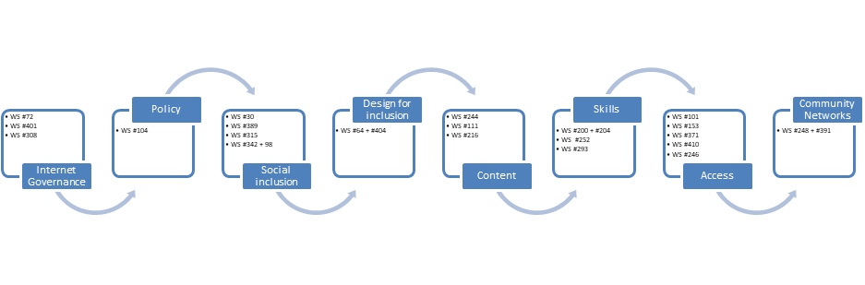
Variation 2

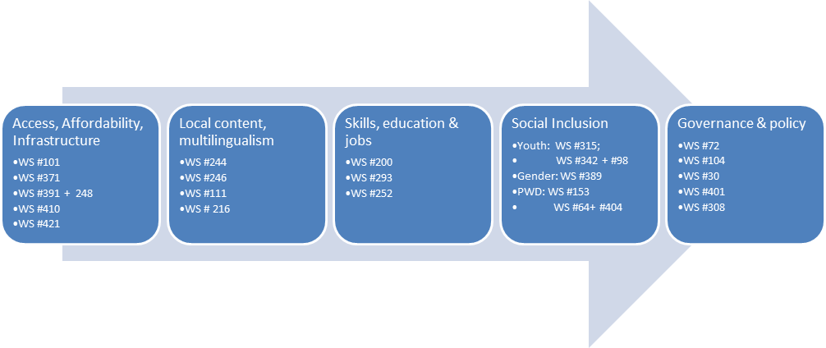

Other suggestions
The group suggests the IGF Secretariat reach out to WS #409 organizers to clarify whether this was meant as a Day 0 event.

